**SYNOPSIS**

Report on

**Job Portal**

**by**

Doulat Biswal – 202410116100070

Dolly Prajapati - 202410116100069

Gargi Gupta - 202410116100071

Gargi Singh – 202410116100072

**Session:2024-2025 (2nd Sem)**

Under the supervision of

**Ms. Shruti Aggarwal**

Assistant Professor

### KIET Group of Institutions, Delhi-NCR, Ghaziabad



### Department Of Computer Applications

**KIET GROUP OF INSTITUTIONS, DELHI-NCR, GHAZIABAD-201206**

(2024 - 2025)

**CERTIFICATE**

Certified that **Doulat Biswal 202410116100070, Dolly Prajapati 202410116100069, Gargi Gupta 202410116100071, Gargi Singh 202410116100072** have carried out the project work having “**Job Portal Application**” (**Mini Project-ID201B**) for **Master of Computer Application** from Dr. A.P.J. Abdul Kalam Technical University (AKTU**)** (formerly UPTU), Lucknow under my supervision. The project report embodies original work, and studies are carried out by the student himself/herself and the contents of the project report do not form the basis for the award of any other degree to the candidate or to anybody else from this or any other University/Institution.

**Ms. Shruti Aggarwal Dr. Akash Rajak**

**Associate Professor Head**

**Department of Computer Applications Department of Computer Applications KIET Group of Institutions, Ghaziabad KIET Group of Institutions, Ghaziabad**

**ABSTRACT**

The **Job Portal** is an innovative web application that simplifies the process of job searching and recruitment by providing a seamless connection between job seekers and employers. By allowing users to search for jobs and post job openings, the platform enhances the hiring process, making it more efficient and accessible. It improves user experience through an intuitive interface and offers advanced filtering options based on job role, location, experience level, salary range, and employment type. Users can save job listings and receive customized recommendations, ensuring a personalized job search experience.

This project addresses key limitations of existing job portals, such as inefficient search functionality and lack of personalized recommendations, by integrating features like advanced filtering, job-saving options, and employer dashboards for application management. The **Job Portal** also includes API integration to provide users with a vast and diverse job database.

With a focus on enhancing user engagement and satisfaction, the **Job Portal** aims to streamline job searching, optimize recruitment efforts, and provide a seamless, efficient hiring experience. The project leverages modern web technologies, including **React, Spring Boot, MongoDB, Redux, Tailwind and Tabler Icons**, ensuring a robust and scalable application.

**Keywords: Job Portal, Recruitment, Job Search, Customization, User Engagement, Web Application**

**ACKNOWLEDGEMENTS**

Success in life is never achieved alone. We express our deepest gratitude to my thesis supervisor, Ms. Shruti Aggarwal (Associate Professor), for her guidance, assistance, and encouragement throughout my project work. Her insightful ideas, comments, and suggestions have been invaluable in helping me complete this project successfully.

We are also immensely grateful to Dr. Akash Rajak, Head of the Department of Computer Applications, for his valuable feedback and administrative support on several occasions. I am fortunate to have many supportive friends who have been of great help during critical moments of this journey.

Lastly, we would like to extend our heartfelt thanks to our family members and all those who have provided us with moral support and assistance, both directly and indirectly. Completing this work on time would not have been possible without their unwavering support. Their constant love and encouragement have filled my life with joy and happiness.

**Doulat Biswal**

**Dolly Prajapati**

**Gargi Gupta**

**Gargi Singh**

**TABLE OF CONTENTS**

Page Number

1. Introduction 4
2. Literature Review 5
3. Project Objective 7
4. Hardware and Software Requirements 9
5. Project Flow 10
6. Project Outcome 12
7. Proposed Time Duration 17
8. References 18

**Chapter 1**

1. **Introduction**
   1. **Background**

In the rapidly evolving digital age, the employment sector has seen a significant transformation. While numerous job portals exist, job seekers still face common challenges such as discovering the right opportunities, filtering jobs based on preferences, and effectively presenting their resumes to recruiters. On the other side, employers often struggle with managing a flood of applications, identifying qualified candidates, and maintaining communication with potential hires. These inefficiencies in traditional hiring systems lead to lost time, missed opportunities, and a lack of transparency between candidates and companies.

The increasing demand for a smarter and more efficient hiring process has led to the development of advanced digital platforms designed to bridge this gap. However, many existing solutions fall short in offering real-time updates, personalization, and user-friendly interfaces. This leads to a frustrating experience for both job seekers and employers, especially for those with limited technical skills.

**Job Seekers** is a modern solution to this age-old problem. It is an interactive, web-based job portal application designed to streamline the recruitment process by connecting job seekers and recruiters through a unified and easy-to-use platform. The motivation behind this project lies in providing a system that not only facilitates job discovery but also enhances the quality of hiring decisions for employers.

This project addresses the gaps in traditional hiring platforms by offering personalized job suggestions, advanced filtering mechanisms, real-time application tracking, and secure communication between users. It introduces a simplified interface for all types of users — whether they are students searching for internships, professionals looking for better opportunities, or organizations aiming to attract top talent.

**Job Seekers** is not just a job board — it's a complete ecosystem built to support the end-to-end hiring lifecycle with an emphasis on accessibility, responsiveness, scalability, and user satisfaction.

* 1. **Project Overview**

Job Seekers is a full-featured job portal application that connects job seekers with recruiters in an efficient, intuitive, and user-friendly way. Developed using a modern web technology stack, the platform serves as a centralized hub for posting jobs, applying for them, and managing the hiring process in real time.

The application supports three primary user roles — job seekers, recruiters, and administrators. Job seekers can create profiles, upload resumes, browse and filter job listings, and apply to relevant positions with just a few clicks. Recruiters can post job openings, review applications, update application statuses, and manage their listings through a dedicated dashboard. Meanwhile, administrators can monitor platform activity, manage users, and moderate content to ensure system integrity and security.

One of the key goals of the platform is to deliver personalized job discovery. By allowing users to set preferences such as location, job type, experience level, and industry, the platform intelligently filters and displays relevant opportunities. Employers can also benefit from this system by receiving qualified applications that closely match the job requirements.

The application integrates user authentication, state management, resume handling, notifications, and role-based access — all within a responsive design that works seamlessly across devices. It is built to scale, enabling future integrations such as AI-based job recommendations, resume builders, interview scheduling tools, and mobile support.

In summary, Job Seekers provides a streamlined and impactful way for users to engage in the job market — whether they are actively searching for work, looking to hire talent, or managing the overall ecosystem.

* 1. **Objective**

The main objectives of **Job Seekers** are:

* To simplify the job search and hiring process for all users.
* To provide personalized job recommendations based on user profiles.
* To enable real-time communication between applicants and recruiters.
* To deliver a secure and scalable platform for job seekers and employers.
* To support administrative control for better data management and monitoring.
  1. **Key Features**
     + **User Registration**: Secure login and profile creation for job seekers and employers.
     + **Job Listings**: Dynamic job posting and visibility based on filters.
     + **Application Tracking**: Real-time application status updates for job seekers.
     + **Admin Dashboard**: Central control panel for monitoring and managing users and listings.
     + **Search & Filter**: Role-based filters for quick and relevant job results.
     + **Notifications**: Alerts for new job postings and application updates.
     + **Resume Upload**: Integrated resume submission for faster application processing.
     + **Role-Based Access**: Separate dashboards and privileges for each user type.
  2. **Scope**
* Can be used by job seekers across different sectors and experience levels.
* Helps companies and recruiters manage job listings and applications efficiently.
* Scalable to integrate features like AI-based job recommendations, resume parsing, and video interviews.
* Can be enhanced with multilingual support and mobile app integration.
* Supports secure communication and privacy of user data.

**Chapter 2**

1. **Literature Review**
   1. **Existing Solutions**

In recent years, online job portals have become the primary medium through which employers connect with potential candidates. Popular platforms such as LinkedIn, Naukri, Indeed, Glassdoor, and Monster have established themselves as leading job marketplaces. These platforms offer a variety of features, including job postings, resume uploads, advanced search filters, and email alerts for job seekers.

Despite their widespread use, these solutions often cater to a broad and generalized audience, leaving behind several critical needs unaddressed. For example, platforms like LinkedIn emphasize networking more than job application workflows, while others may lack effective dashboards for recruiters to manage applications efficiently.

Moreover, many of these platforms do not provide adequate support for customized job recommendations, real-time updates, or interactive employer-candidate communication. The interface is often overloaded with ads, pop-ups, or premium features, which creates an unequal experience between free and paid users.

For new users, particularly fresh graduates or individuals from non-technical backgrounds, the process of searching and applying for jobs can be daunting. On the employer side, manually sorting through thousands of applicants without proper categorization or application tracking tools is inefficient and time-consuming. These shortcomings highlight the need for a more streamlined, purpose-built platform**.**

* 1. **Identified Gaps**

After carefully analysing the features and limitations of existing job portals, the following key gaps have been identified:

* **Lack of Personalization**: Most platforms provide a static list of job openings without adapting the results based on the user's qualifications, interests, or search behaviour. This leads to a mismatch between job seekers and job opportunities.
* **Limited Real-Time Interaction**: Current solutions often do not support real-time notifications regarding application status updates, new job postings, or employer responses. This slows down communication and delays decision-making.
* **Inadequate Employer Dashboards**: Employers are not provided with dynamic tools to sort, filter, or track job applications. There's limited scope to manage the lifecycle of a job post — from publication to final hiring.
* **Lack of Admin Control**: Most platforms do not include a centralized administration module that can oversee platform-wide statistics, manage user reports, verify postings, or enforce platform rules.
* **Overloaded Interfaces**: Cluttered dashboards with multiple pop-ups, ads, and promotional banners hinder the user experience, particularly for those accessing the platform on mobile devices.
* **Security and Role Segregation**: Several platforms do not offer role-specific access or layered security features. A lack of encryption, data validation, or secure file uploads can compromise sensitive user information.
  1. **Importance of The Project**

In The **Job Seekers** application is designed to resolve these gaps with a modern, user-focused approach. It aims to provide a **balanced ecosystem** where both job seekers and employers can interact effectively within a secure and organized framework.

Key contributions of the project include:

* **Streamlined Experience**: By designing clear and minimal user interfaces, users can focus on the task at hand — be it applying for a job or reviewing applications — without distractions.
* **Smart Job Recommendations**: The application can offer suggestions based on the job seeker's profile, qualifications, and previous interactions, improving the relevancy of job results.
* **Role-Based Dashboards**: Separate interfaces for job seekers, employers, and administrators ensure that each user only interacts with the features they need, promoting clarity and security.
* **Live Notifications and Status Tracking**: With real-time updates and alerts, users stay informed about new job postings, application reviews, and status changes — improving transparency and engagement.
* **Security and Data Integrity**: With structured form validation, secure resume handling, and authentication workflows, users can confidently share personal data on the platform.
* **Administrative Control**: Admin users are equipped with the tools to monitor platform usage, verify job listings, handle flagged users or spam, and ensure compliance with usage policies.

The **Job Seekers** platform, therefore, goes beyond traditional job boards by focusing on user empowerment, accessibility, and streamlined functionality. It aligns with the growing need for digital platforms that are intelligent, secure, and tailored to real-world hiring workflows.

**Chapter 3**

1. **Software Analysis**
   1. **Existing Software**

The current job search ecosystem is largely dominated by legacy job portals that offer limited features beyond basic job listings and application submissions. Most of these platforms are generic, offering minimal personalization, limited interaction between employers and applicants, and complex navigation that makes it difficult for users to efficiently complete the hiring or job-seeking process.

Key limitations of the existing systems include:

* **Lack of Targeted Recommendations**: Users receive job listings that may not match their skill set or preferences, leading to lower engagement.
* **Poor Communication Channels**: Once an application is submitted, there is often no mechanism for continuous interaction or feedback between the employer and the applicant.
* **Un-optimised Dashboards**: The tools available to recruiters are often clunky and not designed to handle a large number of applicants efficiently.
* **Limited Role Management**: Most platforms do not support multi-level access control, leading to either restricted access or excessive permissions for certain users.
* **Low System Responsiveness**: Many platforms are not fully responsive across devices, especially on mobile phones, leading to usability issues.
* **Minimal Admin Involvement**: Admins have limited control to manage job listings, users, or suspicious activities, resulting in spam and credibility issues.

These gaps necessitate a new system that can overcome these limitations and deliver a robust, flexible, and scalable platform for both job seekers and employers.

* 1. **Proposed Software**

The **Job Seekers** platform is proposed as a comprehensive, full-stack web application designed to make the job-seeking and hiring process seamless, efficient, and secure. It leverages modern technologies such as **React**, **Tailwind CSS**, **Spring Boot**, and **MongoDB** to ensure speed, performance, and maintainability.

Key highlights of the proposed system include:

* **Role-Based Access**: The system offers three user types — **Job Seekers**, **Employers**, and **Administrators**, each with tailored dashboards and permissions.
* **Secure Authentication**: With built-in support for login, registration, and session management, the platform ensures data privacy and access control.
* **Dynamic Job Listings**: Employers can post, update, or delete job listings dynamically. Listings are displayed in real-time to users based on filters and preferences.
* **Application Tracking**: Job seekers can view the status of their applications (e.g., Pending, Shortlisted, Rejected, Hired) in real time.
* **Search and Filtering**: Advanced search functionalities allow users to find jobs by title, location, type, experience level, and more.
* **Admin Panel**: Admin users can moderate content, manage users, view platform statistics, and ensure that spam or fake postings are flagged or removed.
  1. **Feasibility Study**

Before the actual development, a feasibility study is conducted to determine whether the system is technically, economically, and operationally viable.

**a. Technical Feasibility**

The technologies used in this system — React, Spring Boot, and MongoDB — are widely supported and scalable. Integration between the frontend and backend through REST APIs ensures maintainability and real-time data handling.

**b. Economic Feasibility**

The project is cost-effective since it relies on open-source tools and platforms. Hosting options such as GitHub, Vercel, and Supabase (if used) provide free tiers that are sufficient for development and testing.

**c. Operational Feasibility**

The platform is designed to be user-friendly with minimal learning curve. The system architecture ensures it can be easily adopted by users with different levels of technical knowledge**.**

**Chapter 4**

1. **System Requirements**
   1. **Hardware Requirements**
      * **Processor**: Intel Core i5 or equivalent
      * **RAM**: Minimum 8 GB
      * **Storage**: 100 GB or more (for local development and testing)
      * **Internet connection**: Required for deployment and third-party integrations
   2. **Software Requirements**

|  |  |  |
| --- | --- | --- |
| **Category** | **Technology/Tool** | **Purpose** |
| **Frontend** | React.js | Building interactive and dynamic user interfaces |
|  | TypeScript | Static typing and improved code maintainability |
|  | Tailwind CSS | Utility-first CSS framework for styling |
|  | Redux Toolkit | State management across components |
|  | React Query | Data fetching and caching |
|  | Vite | Fast build tool and development server |
| **Backend** | Java | Backend logic and API development |
|  | Spring Boot | RESTful API framework with dependency management |
|  | Spring Security & JWT | Authentication and role-based access control |
|  | Maven | Build automation and dependency management |
| **Database** | MongoDB | NoSQL database for storing job listings, users, etc. |
|  | Supabase | Cloud-hosted MongoDB solution |
| **Authentication** | Spring Security + JWT | Token-based login and role management |
|  | Supabase | Alternative BaaS for user management and file storage |
| **Version Control** | Git | Version tracking and collaboration |
|  | GitHub | Remote code repository and team collaboration |
| **Testing Tools** | Postman | Testing REST APIs |
|  | JUnit | Backend testing for services/controllers |
| **Others** | Visual Studio Code / IntelliJ IDEA | IDEs for frontend and backend development |
|  | Node.js & npm | Dependency management and running frontend projects |

**Chapter 5**

1. **System Design**
   1. **Architecture Diagram**

The system follows a **3-tier architecture**:

* **Frontend (Client Layer)**: Built using **React**, it provides the user interface for job seekers, employers, and admins. Communication with the backend happens through REST APIs.
* **Backend (Server Layer)**: Powered by **Spring Boot**, it contains the business logic, handles user requests, processes data, and manages user roles and authentication.
* **Database Layer**: **MongoDB** is used for storing user data, job listings, applications, and admin-related information in a flexible, document-based format.
  1. **Component Design**
     1. **Frontend Modules**
* **Home Page**: Displays recent and featured jobs.
* **Login/Register Pages**: Handles user authentication.
* **Dashboard**:
  + **Job Seeker Dashboard**: Apply and track jobs.
  + **Employer Dashboard**: Post and manage jobs.
  + **Admin Dashboard**: Monitor users and jobs.
* **Job Details Page**: View complete job info and apply.
* **Profile Section**: Edit user info, upload resumes, and manage saved jobs.
  + 1. **Backend Modules**
* **Authentication Module**: Handles user login, registration, role-based access using JWT.
* **Job Management Module**: Allows CRUD operations for job postings by employers.
* **Application Module**: Stores job applications and manages their statuses.
* **Admin Module**: Allows viewing reports, managing users, and moderating job listings.
  1. **Database Design**
     1. **Users Collection**
  + userId (Primary Key)
  + name
  + email (unique)
  + role (seeker/employer/admin)
  + password (hashed)
  + resumeLink
  + profileInfo (can store JSON/object with additional profile data)
    1. **Jobs Collection**
  + jobId (Primary Key)
  + title
  + company
  + location
  + type
  + description
  + postedBy (Foreign Key to Users.userId)
  + postedAt (timestamp)
    1. **Application Collections**
  + applicationId (Primary Key)
  + userId (Foreign Key to Users.userId)
  + jobId (Foreign Key to Jobs.jobId)
  + status (pending/shortlisted/rejected)
  + resume (link to resume file)
  + appliedAt (timestamp)

**Relationships:**

* A User (employer) can post many Jobs (one-to-many)
* A User (job seeker) can submit many Applications (one-to-many)
* A Job can receive many Applications (one-to-many)
* Applications serve as a junction between Users and Jobs (many-to-many relationship)
  1. **Data Flow Diagram**
     1. **DFD Level 0**
     2. **DFD Level 1**
     3. **DFD Level 2**

**Chapter 6**

1. **Implementation**
   1. **Frontend Implementation**

The frontend of the system is built using React.js with TypeScript, Tailwind CSS, and Shadcn UI. Key components are implemented to handle dynamic views and user interaction across various roles.

**Major Components**:

* **Login/Register Forms** – For authentication and role assignment.
* **Navigation Bar** – Varies based on user type (Seeker, Employer, Admin).
* **Job Listing Page** – Displays jobs fetched from the backend using React Query.
* **Job Details Page** – Shows full job descriptions and an "Apply" button.
* **Dashboard Pages:**
  + **Job Seeker** – View applied jobs, profile settings.
  + **Employer** – Post jobs, view applications, update status.
  + **Admin** – Manage users and moderate job posts.
* **Forms** – Built using controlled components and integrated with backend via API calls.
* **State Management** – Implemented using Redux Toolkit for handling authentication and job data globally
  1. **Backend Implementation**

The backend is powered by Spring Boot with Java, providing RESTful APIs to handle all business logic and database operations. It uses JWT for secure authentication and MongoDB for data storage.

**Key Rest Endpoints:**

| **Endpoint** | **Method** | **Description** |
| --- | --- | --- |
| /api/auth/register | POST | Registers a new user |
| /api/auth/login | POST | Authenticates and returns JWT token |
| /api/jobs | GET/POST | Retrieves or posts job listings |
| /api/jobs/{id} | PUT/DELETE | Update or delete a job listing |
| /api/applications | POST | Submit a job application |
| /api/applications/user | GET | View applications submitted by user |
| /api/admin/users | GET | Admin: View all users |
| /api/admin/reports | GET | Admin: View analytics and reports |

* 1. **Authentication & Authorisation**

Authentication is implemented using JWT (JSON Web Token). Upon login, the server generates a token containing the user's ID and role. This token is stored on the frontend and used for authorizing all subsequent API requests.

**Features:**

* JWT-based token issuance and validation
* Role-based route protection
* Secure storage of user credentials
* Session persistence using localStorage on the client
* Restricted access to protected routes based on roles
  1. **Integration**

**Write the ccode**

**OKKK Code Here**

**Chapter 7**

1. **Testing**

Testing is a critical phase in the software development lifecycle that ensures the application functions as intended and meets the desired requirements. In the **Job Seekers** project, testing was carried out at various levels—unit testing, integration testing, and system testing—to validate both frontend and backend functionalities.

* 1. **Testing Objectives**
* To verify that all modules (authentication, job posting, application tracking, etc.) work as expected.
* To ensure user interactions and navigation are smooth and error-free.
* To validate backend logic for job matching, filtering, and data storage.
* To catch and fix bugs before deployment.
* To test the system's performance and reliability under different scenarios.
  1. **Types of Testing Performed**
     1. **Unit Testing**
* Focused on individual components such as API endpoints, services, and frontend components.
* Backend unit tests written using **JUnit** and **Mockito**.
* Frontend component tests used manual and visual validation in this phase.
  + 1. **Integration Testing**
* Ensured that modules communicate correctly (e.g., login + dashboard rendering).
* Checked interactions between backend APIs and frontend forms.
* Ensured Redux and React Query states update correctly on API responses.
  + 1. **Manual Testing**
* Carried out for form validation, edge-case user inputs, and navigation.
* Used browser DevTools and console logs to monitor issues.
* Login, registration, job filtering, and status tracking were manually tested.
  + 1. **API Testing**
* Used Postman to simulate user actions like registration, login, posting jobs, and applying.
* Tested with valid/invalid inputs, unauthorized access, and edge cases.
  + 1. **UI/UX Testing**
* Validated responsiveness across screen sizes (desktop, tablet, mobile).
* Checked for consistency in layout, fonts, buttons, and interactions.
  1. **Test Cases Samples**

| **Test Case** | **Expected Result** | **Status** |
| --- | --- | --- |
| Register with valid credentials | Account created, redirected to login | Pass |
| Login with incorrect password | Show error message | Pass |
| Post job without authentication | Denied access, redirected to login | Pass |
| Apply to job as job seeker | Application submitted successfully | Pass |
| Employer updates application status | Status changes reflect on job seeker's dashboard | Pass |

**Chapter 8**

1. **Results**
   1. **Results Achieved**

After completing the development and implementation of the Job Seekers portal, the following results were successfully achieved:

* + 1. **User Registration & Login**: Secure registration and login features were developed with role-based access for job seekers, employers, and admins.

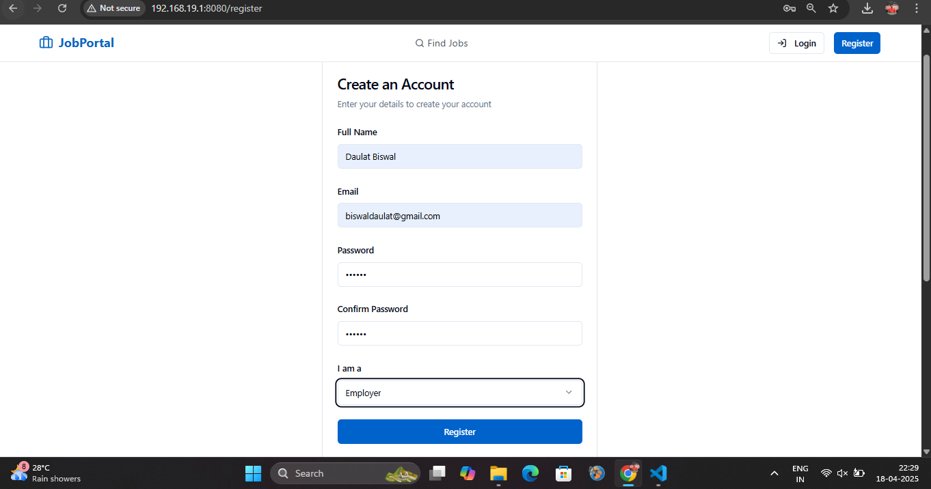

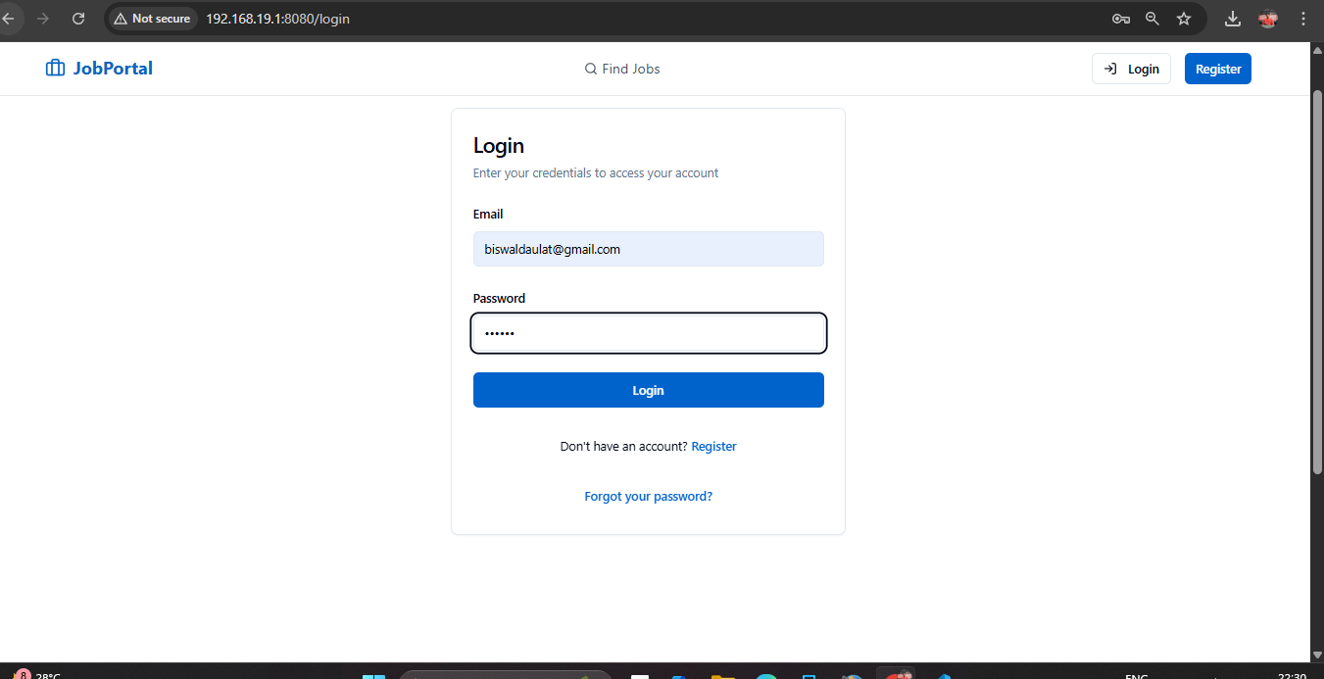

* + 1. **Job Listings & Filters**: A dynamic job board was implemented, enabling users to search, browse, and filter jobs based on role, location, type, and experience.

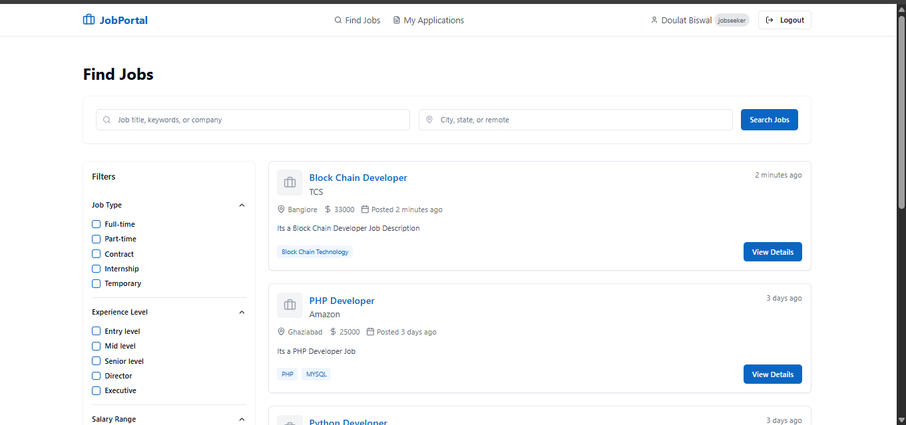

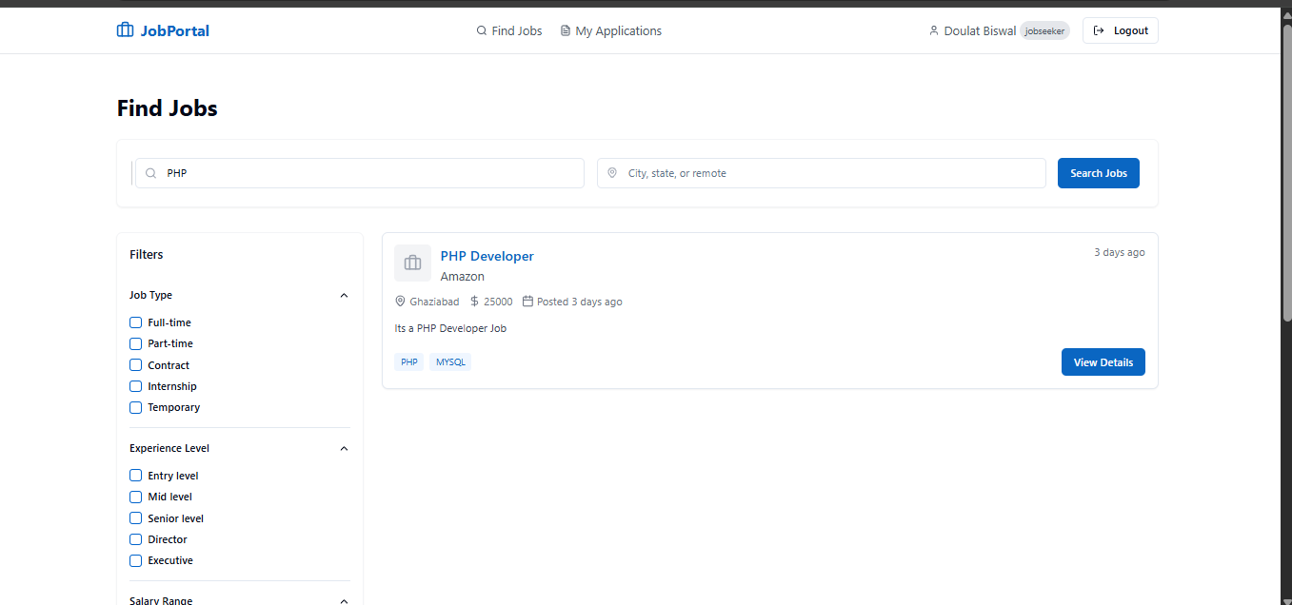

* + 1. **Job Application System**: Job seekers were able to apply for jobs with resumes and view application statuses in real-time.

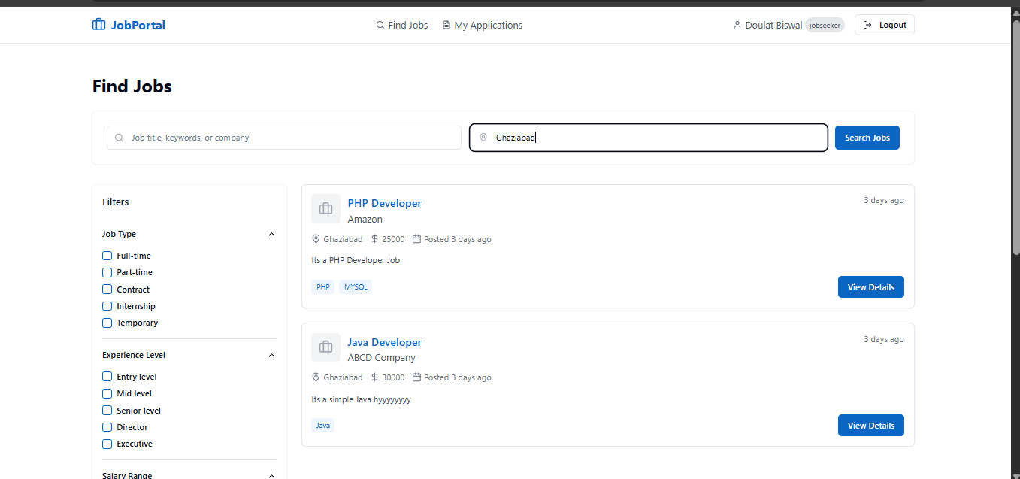

* + 1. **Employer Dashboard**: Employers could post new jobs, view applicants, and update.

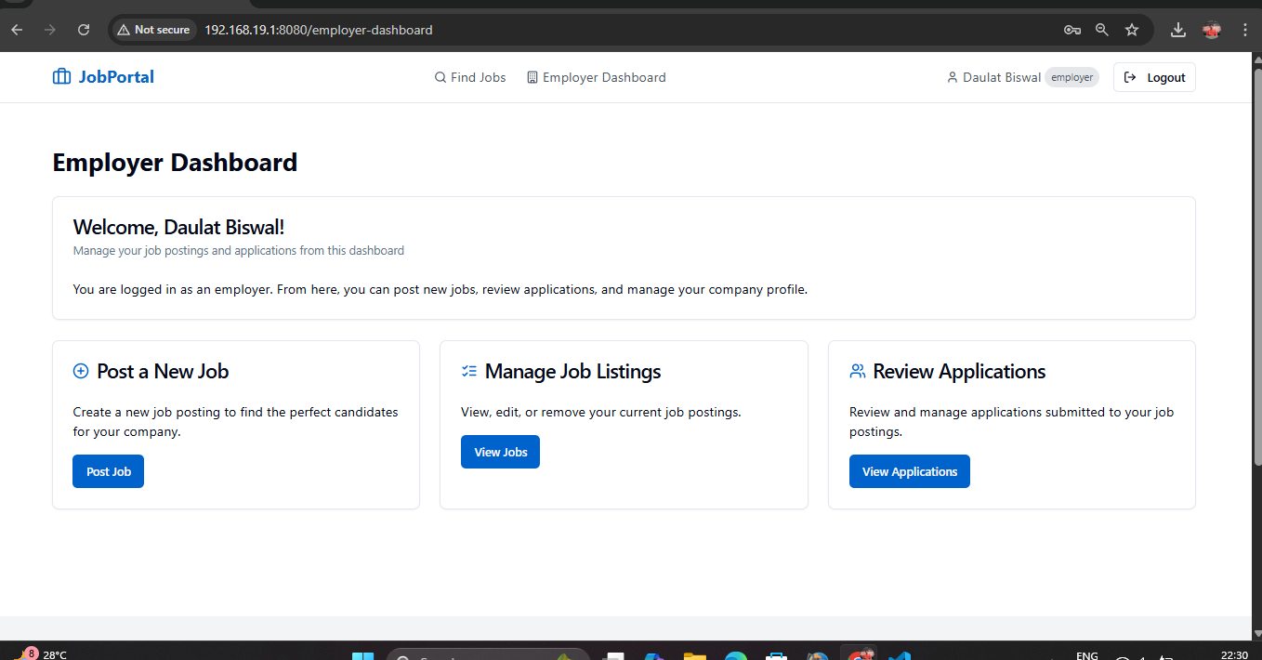

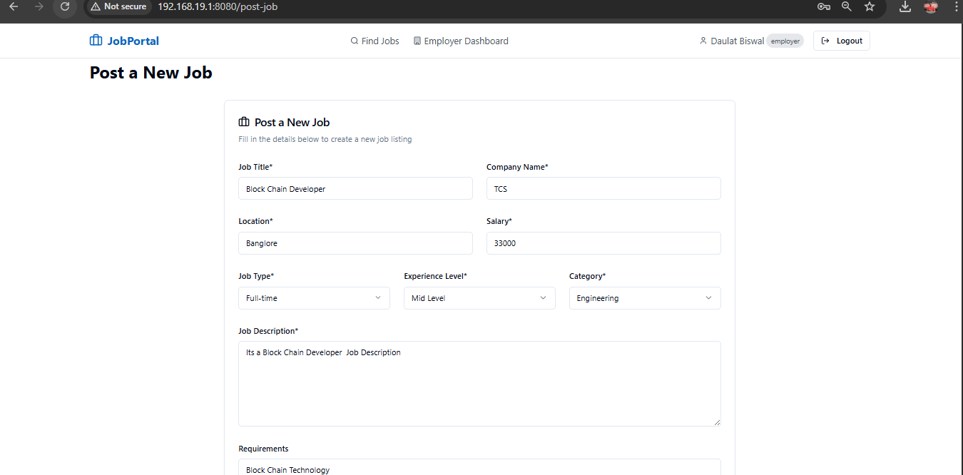

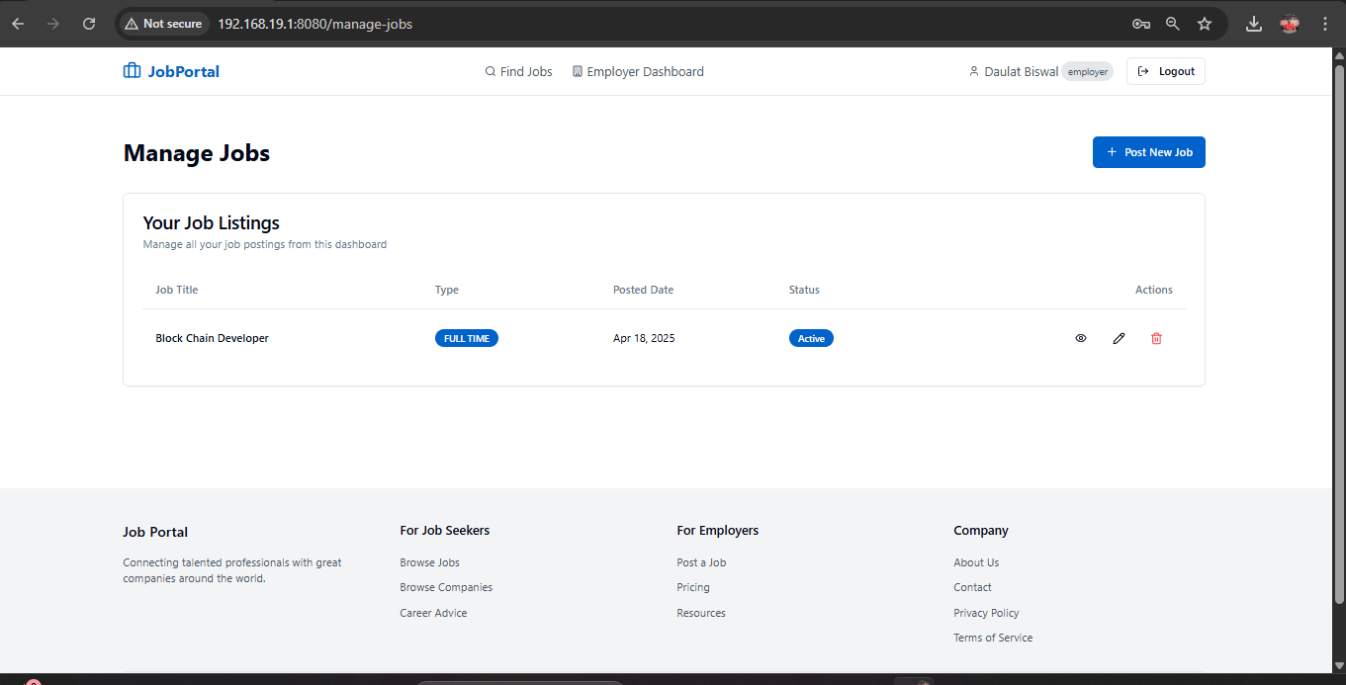

* + 1. **Admin Control Panel**: Admin functionalities such as monitoring users and moderating job posts were fully implemented.
    2. **Responsive UI**: The application works smoothly across desktops, tablets, and mobile devices.
    3. **Secure Data Handling**: JWT authentication and database-level access control were successfully integrated for user safety.
  1. **Observation & Insights**
* User Interface Feedback: Initial feedback indicated the UI was user-friendly and intuitive, thanks to the use of Tailwind and Shadcn components.
* Backend Performance: Spring Boot provided a fast and secure API environment, capable of handling multiple user roles without conflict.
* Role Separation: Role-based routing and interface separation greatly improved the user experience for job seekers and employers.
* Integration Challenges: Some delays occurred during the integration of frontend and backend, especially with authentication and token handling, but were resolved with debugging and clear communication between modules.
* Real-time Updates: Users appreciated the real-time status updates on job applications, improving engagement and transparency.
  1. **Limitations & Areas for Improvements**
* Limited Notifications: The current system lacks email or push notifications for new job posts or application updates.
* No Resume Parsing: Resume files are stored but not parsed for data insights, which could improve job recommendations.
* No Chat Feature: Direct communication between employer and applicant is not yet implemented.
* Analytics: The admin panel could benefit from more visual analytics for monitoring platform activity.

**Chapter 9**

1. **Conclusion**

The development of the Job Seekers platform marks a significant step toward modernizing and simplifying the job search and recruitment process. In today’s competitive employment landscape, it is essential to create a seamless digital bridge between job seekers and employers. This project effectively addresses that need by delivering a full-featured, user-friendly, and scalable solution.

Through the course of the project, we focused on creating a multi-role application where users can register as job seekers, employers, or administrators, each with distinct dashboards and access privileges. Job seekers are empowered to explore job listings, apply with their resumes, and track their application statuses, while employers have access to intuitive tools for posting jobs and managing applications. Administrators have control over the platform, ensuring smooth operations, security, and moderation.

The system architecture was built on a solid foundation of React.js for the frontend, Spring Boot for the backend, and MongoDB for data storage. The user interface, designed using Tailwind CSS and Shadcn UI, ensures responsiveness and ease of use across all devices. The integration of Redux Toolkit and React Query enhanced state management and asynchronous data handling. Secure authentication was achieved using JWT (JSON Web Tokens), ensuring that only authorized users access sensitive features and data.

The platform was thoroughly tested at different levels—unit testing, integration testing, and manual testing—to ensure a high degree of reliability, accuracy, and user satisfaction. The results from our testing phase showed that all major features were functioning as expected and provided a smooth user experience.

One of the most important outcomes of this project is not just the technical achievement but the potential social impact. The platform can make a real difference in the lives of job seekers by helping them discover opportunities aligned with their skills and interests, and supporting companies in reaching the right talent quickly and efficiently.

This project also provided a deep learning experience in full-stack development, from building secure RESTful APIs to creating interactive user interfaces and handling real-world application workflows. The knowledge gained will serve as a valuable foundation for future enhancements and scaling the application to meet broader use cases.

In summary, the Job Seekers application has met its goals of efficiency, security, and usability. It serves as a modern, reliable platform that can adapt and grow with user needs, paving the way for a smarter job-hunting and hiring ecosystem.

**Future Enhancement:**

While the current implementation of the **Job Seekers** portal provides a robust foundation for job searching and recruitment, there are numerous opportunities for further improvement and innovation. As the application scales and user needs evolve, the following future enhancements are proposed to extend its capabilities:

**1. AI-Powered Job Recommendations**

Integrating artificial intelligence can significantly enhance the platform's ability to suggest personalized job opportunities to users. By analyzing a user’s resume, previous applications, skills, and preferences, the system could intelligently recommend jobs that closely align with their career goals.

* AI matching based on profile & resume
* Learning user preferences over time
* Job ranking based on compatibility score

**2. Resume Builder Tool**

A built-in resume builder would allow users to create professional, ATS-friendly resumes directly on the platform. This would be particularly beneficial for freshers or users with limited technical expertise.

* Pre-designed templates
* Auto-fill from profile information
* PDF download and in-app storage

**3. Real-Time Chat System**

Introducing a secure chat system between employers and job seekers would facilitate direct communication. This could speed up the hiring process by allowing both parties to clarify job expectations, scheduling interviews, or discussing roles without relying on external tools.

* End-to-end encrypted messaging
* Message history tracking
* Admin moderation and report functionality

**4. Email and Push Notifications**

Users should receive timely notifications about important updates such as new job postings, application status changes, or messages from employers.

* Email alerts for new job matches
* In-app notification system
* Reminders for incomplete profiles or pending applications

**5. Employer Verification & Trust Scores**

Implementing a trust score or verification process for employers can improve the credibility and trustworthiness of job listings. Verified companies would be highlighted and users can provide ratings based on their application experience.

* Document-based employer verification
* User reviews and trust badges
* Employer history and performance data

**6. Analytics Dashboard for Admins**

Providing visual insights and statistics to admins would enhance system management. Admins could monitor platform growth, job trends, user engagement, and application success rates through an interactive dashboard.

* Graphs and charts for job postings
* User growth analysis

**7. Multilingual Support**

To make the platform more inclusive, multilingual support can be added to cater to users from different linguistic backgrounds, especially in countries with diverse populations.

* Language toggle in UI
* Translation of job posts and system messages
* RTL language support

**8. Mobile Application**

Developing a dedicated Android and iOS application would improve accessibility, enabling users to interact with the platform on-the-go with push notifications and mobile-optimized UX.

* Native performance on Android/iOS
* Offline resume access
* Biometric login support

These proposed additions aim to enhance usability, improve user engagement, and increase the platform’s effectiveness as a modern, intelligent job portal system. As more users engage with the platform, gathering feedback and iterating on these ideas will be key to future growth.

**Chapter 10**

1. **Reference**
2. **React.js Official Documentation**

h<ttps://reactjs.org/docs/getting-started.html>

1. **Spring Boot Reference Guide**

<https://docs.spring.io/spring-boot/docs/current/reference/html/>

1. **MongoDB Documentation**

<https://www.mongodb.com/docs/>

1. **Tailwind CSS Documentation**

<https://tailwindcss.com/docs>

1. **Redux Toolkit Documentation**

<https://redux-toolkit.js.org/>

1. **JWT (JSON Web Token) Introduction**

<https://jwt.io/introduction/>

1. **Postman – API Development & Testing Tool**

<https://www.postman.com/>

1. **GitHub – Code Hosting Platform**

<https://github.com/>

1. **Supabase Documentation**

<https://supabase.com/docs>

1. **VS Code – Code Editor**

<https://code.visualstudio.com/>